CA3 Project report
By: Ethan Ford X number: X00197969
Introduction
This is my report on the blazor web application made for app development CA3. The goal is to show I can handle and call a public API properly. In this project I use C# for the logic, Html and CSS for front end and styling, and GitHub Actions for the CI/CD.
The project uses PokeAPI (link) for the public API. It returns detailed data about Pokémon’s which I use to allow the user to search for Pokémon and their stats as well as allowing the user to enter their height and weight to find their closest matching Pokémon. The application is fully hosted online as I deployed it using GitHub Actions.
Here is a look at the two pages in my project: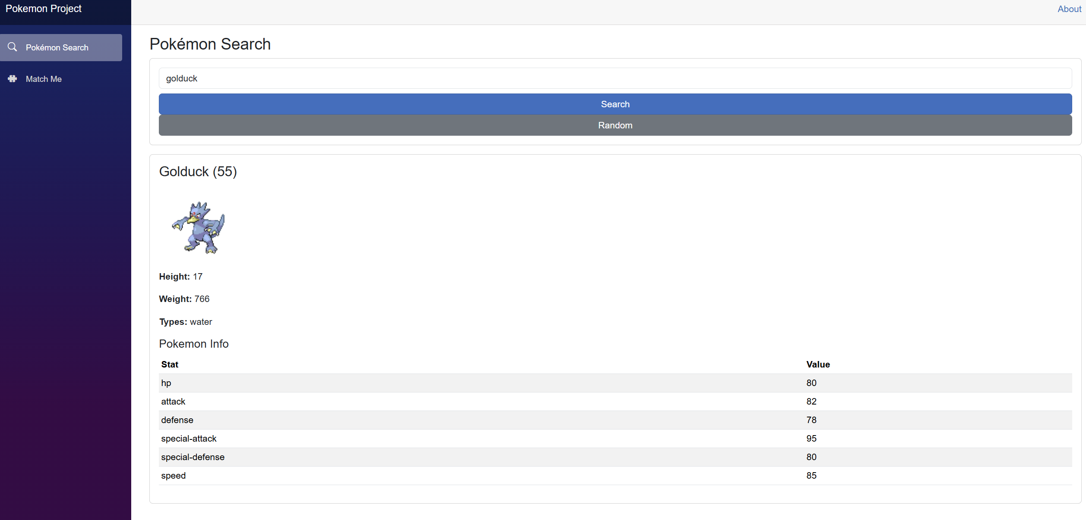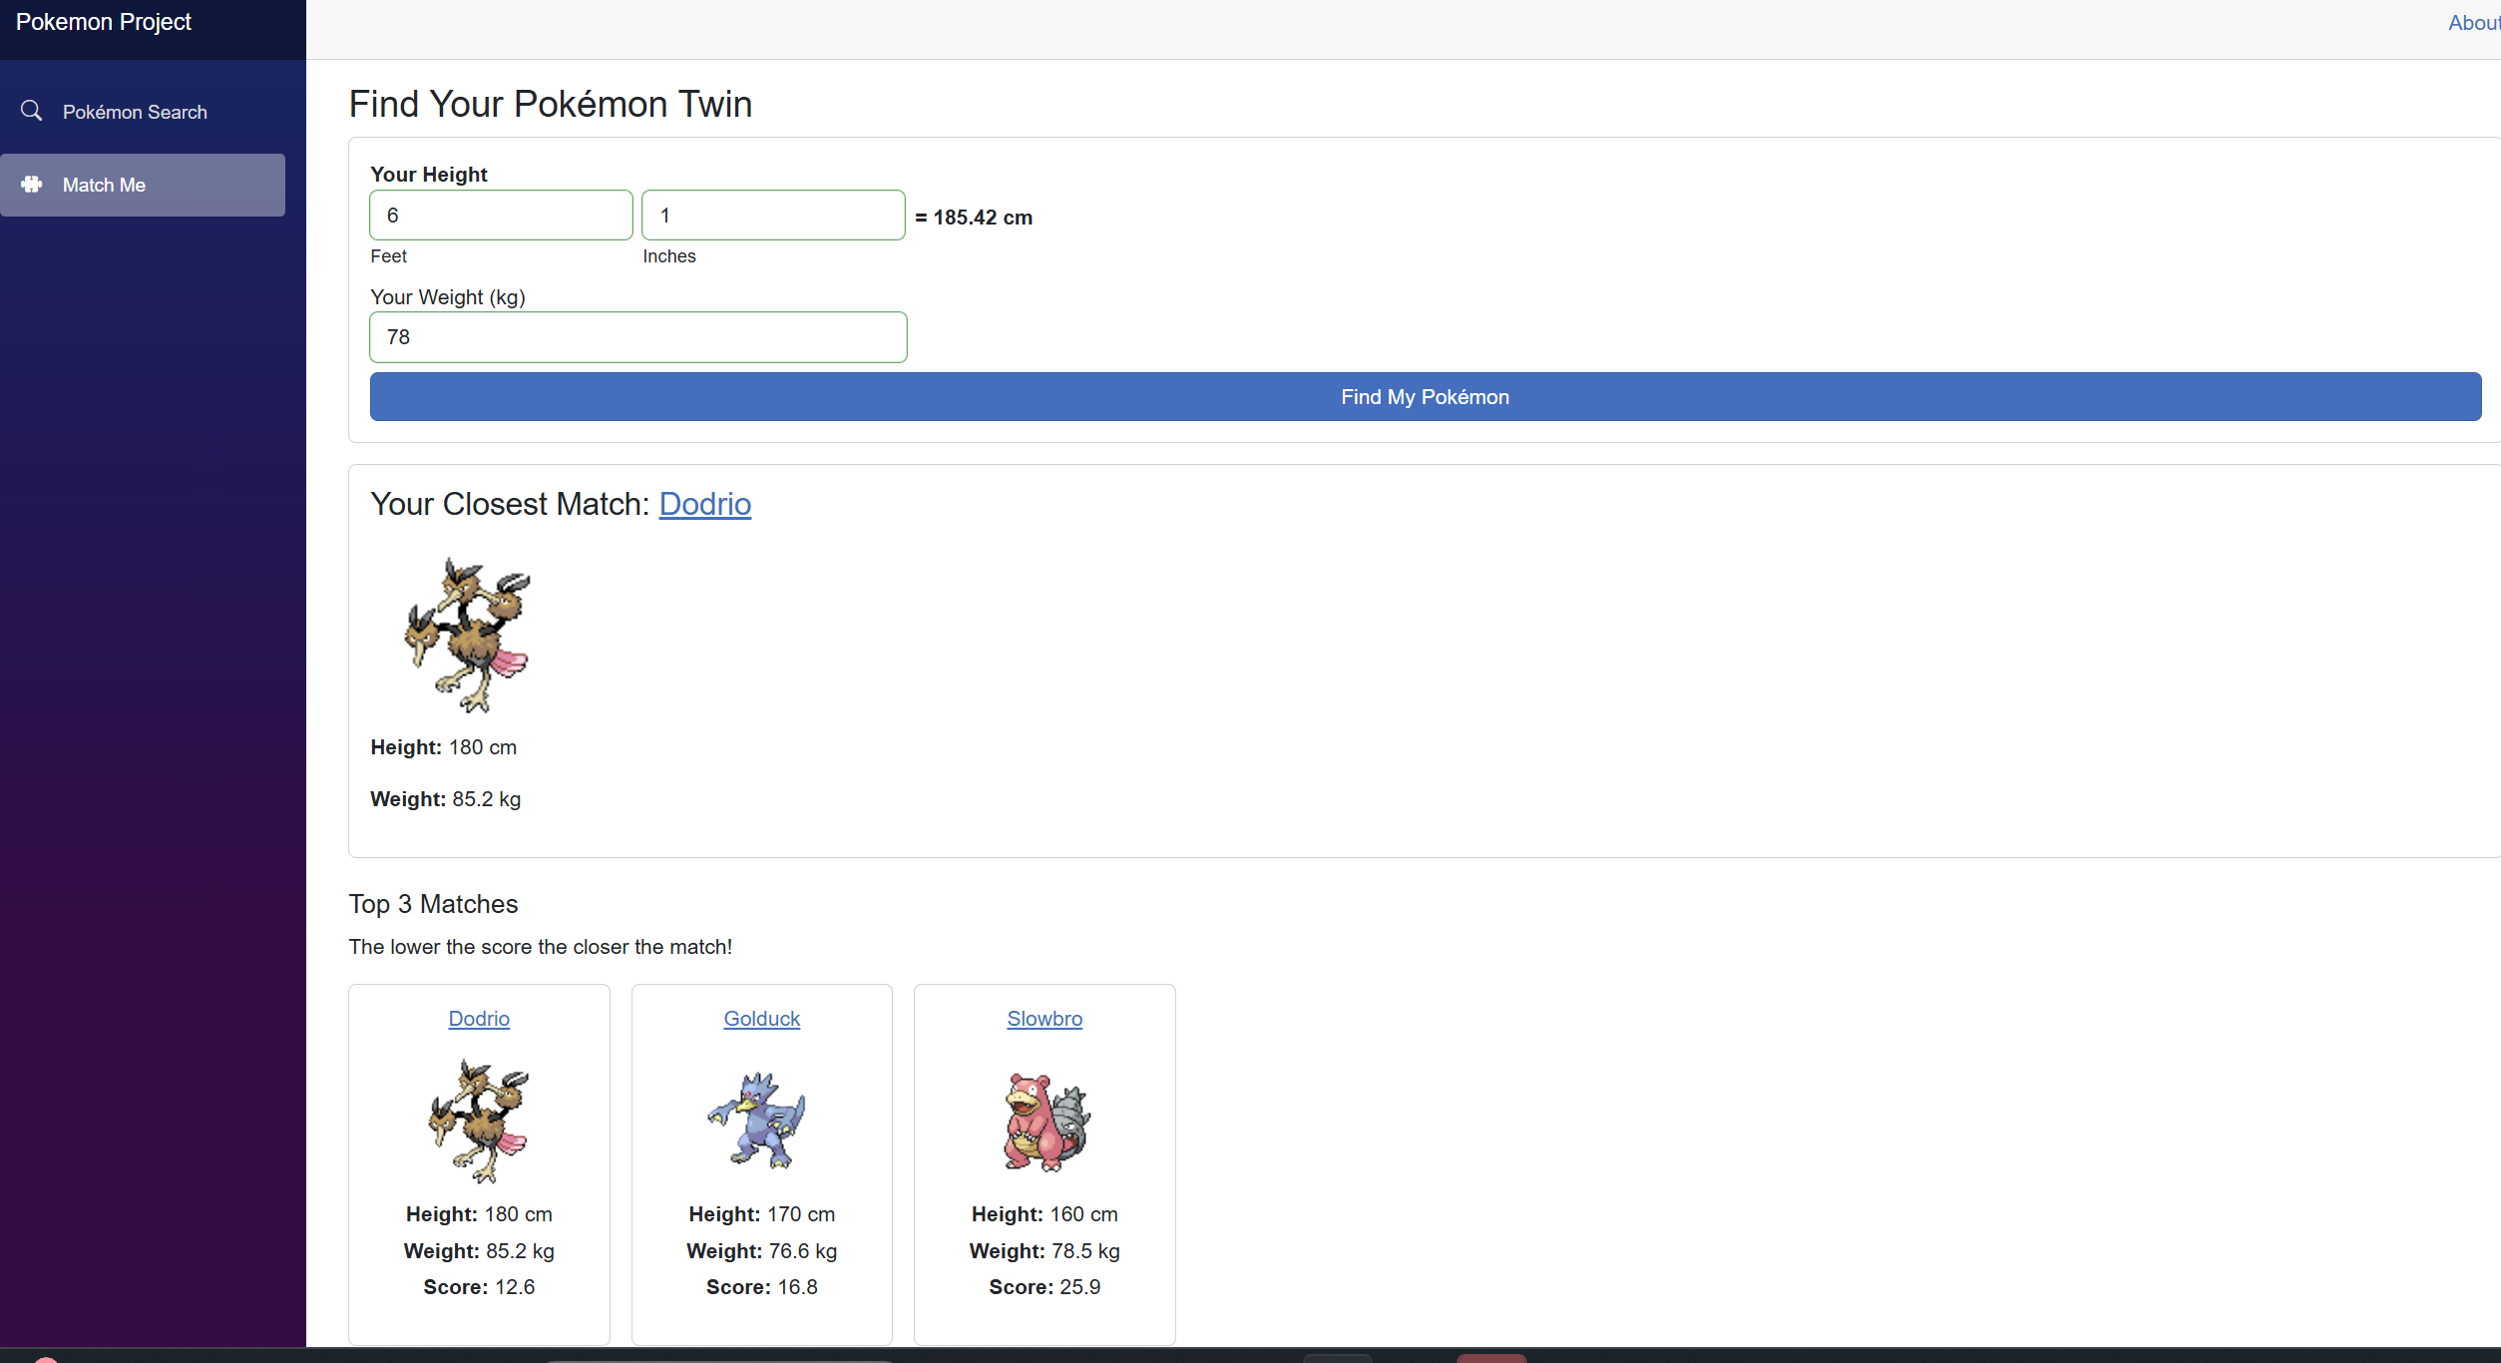

Overview
I built the application using ASP.NET Core Blazor Web Assembly and it has three main features.
- Search for specific Pokémon by name or Id
- Display a random Pokémon
- Find your closest matching Pokémon by height and weight.
- This works by taking your height and weight away from theirs and adding the remainders together to get a score for each Pokémon. The lower the score the better the match.
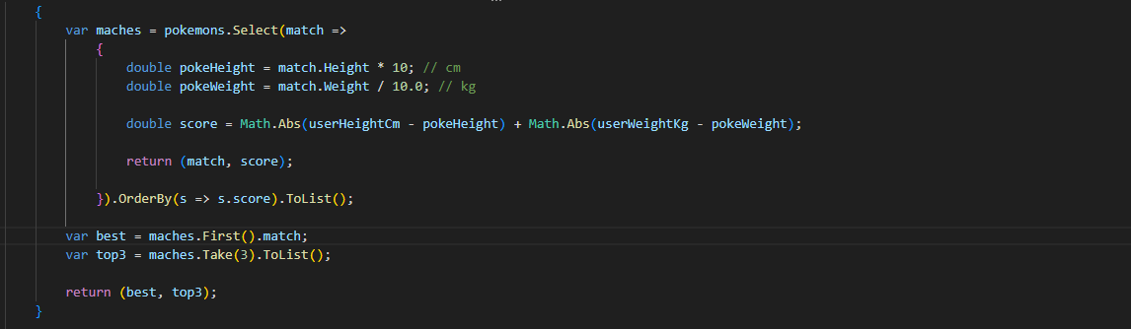
The height is entered as feet and inches then converted to cm. This is done because the API stores the Pokémon height as Decimetres (dm). One decimetre converts to ten centimetres and people don’t often know their height in centimetres, so I take it from feet and inches and then covert both to centimetres as a common ground for any calculations. I also display the cm conversion of the user’s height to it is easier to relate to the Pokémon’s stats.
The weight was easier as it is stored in the API as hectograms (hg) which converts to ten times the weight of kilograms. Since kilograms are commonly used I let the user enter their weight in kg, so I only needed one conversion.
After you find your match, you can press on the Pokémon’s name, and it will bring you to the search page and show you more detail about the Pokémon you selected.

Testing
I used XUnit test in pokemon.tests to test if the Height conversion, search and matching algorithm worked properly.
Example:
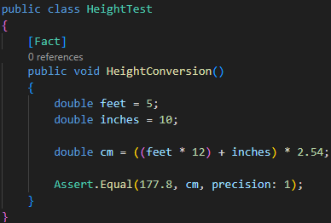
I then used Play wright for end-to-end testing where I could record my inputs while traversing the website. I put this in its own separate folder from the other tests as it is a completely different type of test and runs differently. In the script it automates:
- Opening the app
- Searching for “pikachu”
- Navigating pages
- Using the Match Me form
- Checking the final result

CI/CD pipeline
I created the pipeline with GitHub actions and used it to:
- checkout the repository. - Sup up .NET
- Run tests - link index.html
- Build app - Deploy to GitHub
Hosted URL: Project
GitHub URL: Repo

Conclusion
After going through the requirements, the project includes:
- public JSON API
- Interactive features/calculations
- Error handling
- Clean folder and code organization
- Unit test and E2E testing
- Regular commits and version control
- Fully deployed using CI/CD
- Hosted publicly

